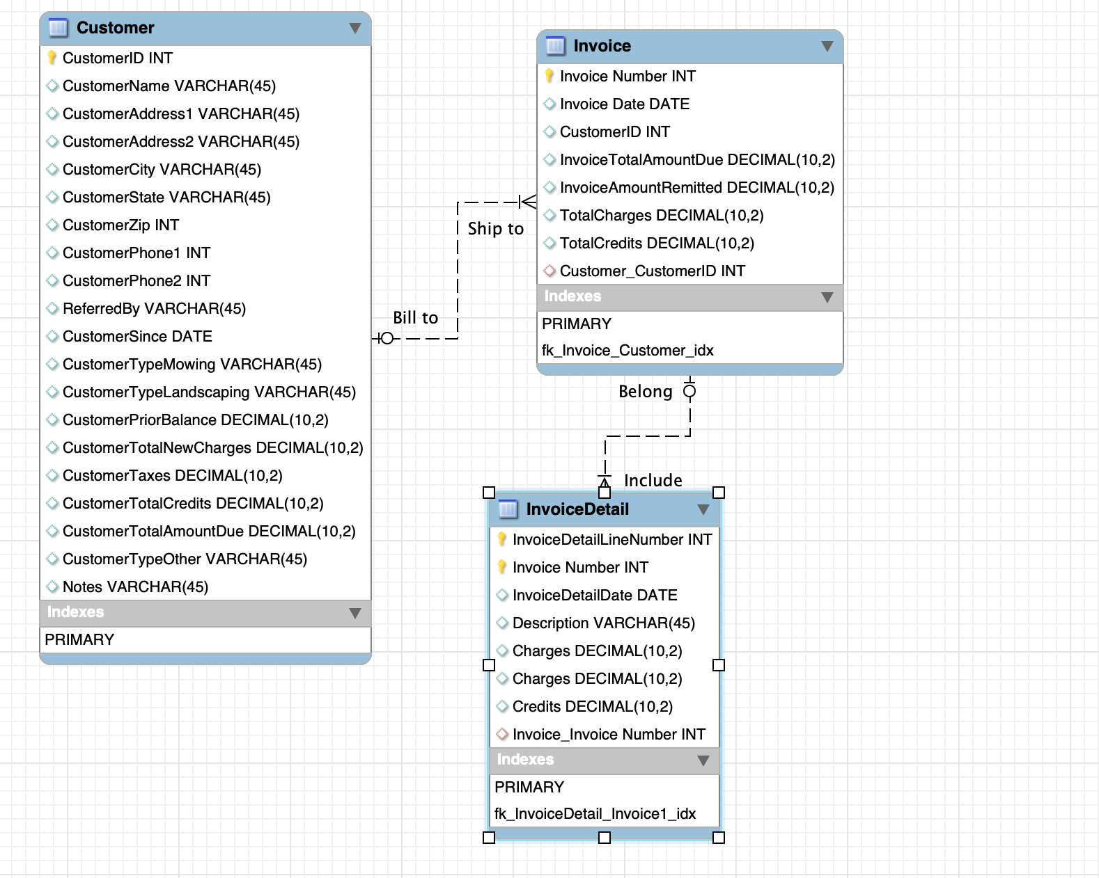

-- MySQL Script generated by MySQL Workbench

-- Thu Jun 20 18:48:30 2019

-- Model: New Model Version: 1.0

-- MySQL Workbench Forward Engineering

SET @OLD_UNIQUE_CHECKS=@@UNIQUE_CHECKS, UNIQUE_CHECKS=0;

SET @OLD_FOREIGN_KEY_CHECKS=@@FOREIGN_KEY_CHECKS, FOREIGN_KEY_CHECKS=0;

SET @OLD_SQL_MODE=@@SQL_MODE, SQL_MODE='TRADITIONAL,ALLOW_INVALID_DATES';

-- -----------------------------------------------------

-- Schema mydb

-- -----------------------------------------------------

DROP SCHEMA IF EXISTS `mydb` ;

-- -----------------------------------------------------

-- Schema mydb

-- -----------------------------------------------------

CREATE SCHEMA IF NOT EXISTS `mydb` DEFAULT CHARACTER SET utf8 ;

USE `mydb` ;

-- -----------------------------------------------------

-- Table `mydb`.`Customer`

-- -----------------------------------------------------

DROP TABLE IF EXISTS `mydb`.`Customer` ;

CREATE TABLE IF NOT EXISTS `mydb`.`Customer` (

`CustomerID` INT NOT NULL,

`CustomerName` VARCHAR(45) NULL,

`CustomerAddress1` VARCHAR(45) NULL,

`CustomerAddress2` VARCHAR(45) NULL,

`CustomerCity` VARCHAR(45) NULL,

`CustomerState` VARCHAR(45) NULL,

`CustomerZip` INT NULL,

`CustomerPhone1` INT NULL,

`CustomerPhone2` INT NULL,

`ReferredBy` VARCHAR(45) NULL,

`CustomerSince` DATE NULL,

`CustomerTypeMowing` VARCHAR(45) NULL,

`CustomerTypeLandscaping` VARCHAR(45) NULL,

`CustomerPriorBalance` DECIMAL(10,2) NULL,

`CustomerTotalNewCharges` DECIMAL(10,2) NULL,

`CustomerTaxes` DECIMAL(10,2) NULL,

`CustomerTotalCredits` DECIMAL(10,2) NULL,

`CustomerTotalAmountDue` DECIMAL(10,2) NULL,

`CustomerTypeOther` VARCHAR(45) NULL,

`Notes` VARCHAR(45) NULL,

PRIMARY KEY (`CustomerID`))

ENGINE = InnoDB;

-- -----------------------------------------------------

-- Table `mydb`.`Invoice`

-- -----------------------------------------------------

DROP TABLE IF EXISTS `mydb`.`Invoice` ;

CREATE TABLE IF NOT EXISTS `mydb`.`Invoice` (

`Invoice Number` INT NOT NULL,

`Invoice Date` DATE NULL,

`CustomerID` INT NULL,

`InvoiceTotalAmountDue` DECIMAL(10,2) NULL,

`InvoiceAmountRemitted` DECIMAL(10,2) NULL,

`TotalCharges` DECIMAL(10,2) NULL,

`TotalCredits` DECIMAL(10,2) NULL,

`Customer_CustomerID` INT NULL,

PRIMARY KEY (`Invoice Number`),

INDEX `fk_Invoice_Customer_idx` (`Customer_CustomerID` ASC),

CONSTRAINT `fk_Invoice_Customer`

FOREIGN KEY (`Customer_CustomerID`)

REFERENCES `mydb`.`Customer` (`CustomerID`)

ON DELETE NO ACTION

ON UPDATE NO ACTION)

ENGINE = InnoDB;

-- -----------------------------------------------------

-- Table `mydb`.`InvoiceDetail`

-- -----------------------------------------------------

DROP TABLE IF EXISTS `mydb`.`InvoiceDetail` ;

CREATE TABLE IF NOT EXISTS `mydb`.`InvoiceDetail` (

`InvoiceDetailLineNumber` INT NOT NULL,

`Invoice Number` INT NOT NULL,

`InvoiceDetailDate` DATE NULL,

`Description` VARCHAR(45) NULL,

`Charges` DECIMAL(10,2) NULL,

`Charges` DECIMAL(10,2) NULL,

`Credits` DECIMAL(10,2) NULL,

`Invoice_Invoice Number` INT NULL,

PRIMARY KEY (`InvoiceDetailLineNumber`, `Invoice Number`),

INDEX `fk_InvoiceDetail_Invoice1_idx` (`Invoice_Invoice Number` ASC),

CONSTRAINT `fk_InvoiceDetail_Invoice1`

FOREIGN KEY (`Invoice_Invoice Number`)

REFERENCES `mydb`.`Invoice` (`Invoice Number`)

ON DELETE NO ACTION

ON UPDATE NO ACTION)

ENGINE = InnoDB;

SET SQL_MODE=@OLD_SQL_MODE;

SET FOREIGN_KEY_CHECKS=@OLD_FOREIGN_KEY_CHECKS;

SET UNIQUE_CHECKS=@OLD_UNIQUE_CHECKS;

Assumptions:

1. It is mandatory that each invoice corresponding to one customer.
2. It is not necessary that each customer to have an invoice. Customer can have invoice corresponding to him/her or each customer can no invoice correspond to him/her.
3. For invoice and invoice detail, it is mandatory to have corresponding relationship both ways. Each invoice needs to have invoice detail. And each invoice detail need to have invoice corresponding to it.